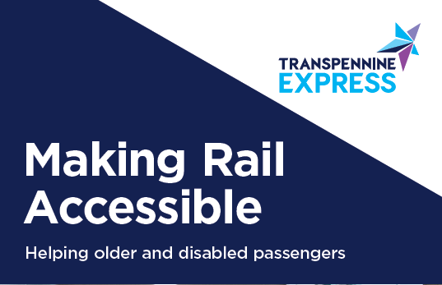

August 2019

Making Rail Accessible

Travelling on NOVA 3

Welcome to NOVA 3
NOVA 3 is the first of three brand new fleets of trains to join TransPennine Express. Comprised of five carriages, powered by a Class 68 locomotive it offers more space, more seats, faster journeys, and a true intercity experience for our customers.
We’ll be introducing 13 of these trains in total, taking over from our Class 185 trains between Liverpool Lime Street and Scarborough, and between Manchester Airport and Middlesbrough.
This guide is designed to complement our Making Rail Accessible guides, and help you to plan your journey on NOVA 3, giving you all the information you need to know about accessing the train and what to expect whilst you’re on board.
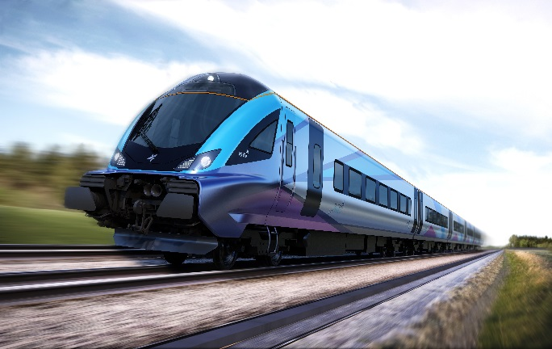

Key Features
These state-of-the-art trains have been designed to offer the best possible experience for all customers on board, and are fully compliant with the latest accessibility regulations.
Key features include:
- 261 standard class seats, with 32 identified as priority seats
- 30 first class seats, with 3 identified as priority seats
- Two dedicated wheelchair user spaces with companion seats
- Three toilets plus one accessible toilet with baby changing facilities
- Large luggage stacks in every carriage, with more space for luggage between seat backs
- Large overhead luggage racks
- Digital seat reservations with ‘traffic light’ availability notices
- Audio/visual announcements
- Contrasting grabrails
- Tactile notices and controls
- Digital displays
- Ramped access available at every door
- Free Wi-Fi and media servers on board with Exstream
- Power sockets and USB charging at every pair of seats in standard class, and at every seat in first class
We want to ensure that you are able to make the most of all of these features. The next few pages of this guide explore the detail of how these features work for customers with additional needs, and the steps which you can take as a customer to help us to help you whilst travelling on our trains.

Introduction into Service
NOVA 3 trains will enter service in 2019. Their introduction will be phased so that we can use each new train as they’re ready to add much needed capacity across our network as soon as we can.
By taking this phased approach, during the transition from Class 185s to NOVA 3 on these two routes, we will experience limitations with some on board systems, including reservations.
We have compared the seat and carriage numbering of our class 185 fleets with our NOVA 3 trains, and wherever possible, will make seats reservable, however as NOVA 3 has more carriages, and some key customer features such as first class, wheelchair user spaces and cycle spaces have moved coaches, we will be operating a hybrid approach to our reservations.
What does this mean for customers?
For wheelchair users, where the service you are travelling on could be operated by either a class 185 or a NOVA 3, the wheelchair user space will show as E1 or E2 with staff aware that if the train is a class 185, the wheelchair user spaces are in coach C.
For first class customers, seats will be available on a first come, first served basis. On NOVA 3 trains, our conductors and on board hosts will endeavour to make available the companion seats next to the wheelchair user spaces where required.
For priority seat users, our conductors and on board hosts will endeavour to make available the seating you require.

Boarding and Alighting the Train

Coach Labels
Digital displays on the exterior of the train identify the destination of the train and each of the coaches with fixed labelling applied indicating which coach contains the wheelchair user spaces.
In addition to this, the configuration of the NOVA 3 train enables customers to quickly recognise which end of the train is which. The coach closest to the class 68 locomotive which powers the train is coach E, with first class, two wheelchair user spaces and the universal toilet.

Ramped access at all doors
Ramps can be positioned at all passenger doors on NOVA 3 trains, recognising that some customers, such as those using walking frames, rollators or walking sticks may benefit from boarding using the ramp, but are not necessarily wheelchair users.
Customers preferring to use the ramp to board can help us by booking assistance in advance so that station teams can be in position with the ramp. Priority seating can also be reserved.
To minimise delays, we advise that customers requiring the ramp to board and alight the train travel in coach E (first class) or coach D (standard class) recognising that the on-board ramp is stored in the vestibule of coach E.

On the Train

Reservations
Our NOVA 3 trains have digital seat reservations with ‘traffic light’ availability notices.
The traffic light system shows different colours depending on the current availability of the seat.
RED
There is a current reservation. Customers with a seat reservation will find the traffic light above their seat illuminated in red, and scrolling text showing where the seat is reserved from and to.
YELLOW
There will be a future reservation. Customers who have not reserved a seat can sit in this seat until the point at which it becomes reserved, which is displayed as scrolling text.
GREEN
This seat is available until the end of the journey. Customers without a reservation can sit in this seat until the end of the journey.
This reservation system also applies to the wheelchair user spaces and cycle storage spaces.
If no light is displayed, the system is inactive. Customers are advised to find the closest available seat which meets their needs and are reminded of the provision of priority seats available throughout the train which are well placed for those who are disabled, pregnant or less able to stand.
Reservations during fleet introduction
During the phased introduction of this fleet, the reservation system will not be in full effect, and during this time, we will operate with ‘counted places’ reservations for some seating types, allowing our new and current fleets to be interchangeable.
Reservations for a small number of standard class seats will be in operation, where the seat numbers on the NOVA 3 fleet align to the seat numbers on our Class 185 fleet.
Reservations for priority seats, wheelchair user spaces and cycle spaces can be made, with set quotas for each, however a seat number and reservation label may not be allocated. This is because the seat and carriage numbers are different on the two fleets, and the reservations system is unable to determine which type of train is being used for each service until all NOVA 3 trains are in operation.
Passenger Assistance will remain available, and customers can book the wheelchair user spaces and priority seating on board, however the details on the passenger assist booking confirmation may not correspond fully with where you are located on the train.
For example, a wheelchair user assistance booking will show E1 or E2 based on where the wheelchair user spaces are located on a NOVA 3 train, however if the service operates using a class 185 train, the wheelchair user space will be C98 or C99.
Staff will be briefed of these arrangements and will take steps to support customers whilst travelling, ensuring the requested assistance is not impacted by this transitional period.

Priority Seating
Our NOVA 3 trains benefit from priority seating in every carriage, including in first class. These seats offer additional legroom, and are conveniently placed close to the ends of the carriage.
Priority seats are particularly useful for customers who may need extra legroom, are unable to walk to a seat further down the carriage, want staff to be aware that they may need a little extra help, or need a seat because they are unable to stand for longer periods.
All priority seating on TransPennine Express trains have clear signage so that customers know which seats these are.
You can see which are the priority seats on board by referring to the train layout on page 11 of this guide.
Customers are able to reserve a priority seat in advance and request assistance from our station and on-board teams to help whilst in the station and when boarding the train by contacting our Assisted Travel team. Details of how to book assistance can be found in our guide Making Rail Accessible: Helping Older and Disabled customers, available on our website, or from any staffed station where our services call.

Luggage
Luggage space on board NOVA 3 is greatly increased in comparison to our class 185 fleet with luggage stacks in each coach, large overhead racks and additional storage between seat backs.
Customers requiring assistance with luggage can request this in advance by contacting our Assisted Travel Team or by seeking help from station or on-board staff. If you require luggage assistance, please bear in mind that staff must be able to lift your luggage safely, so please give thought to the weight and quantity of items you bring with you.
You may take up to three items of luggage on our trains with you in line with the National Rail Conditions of Travel. More information can be found at tpexpress.co.uk/travelling-with-us/onboard-facilities/what-you-can-bring-on-board

Audio and Visual Information
Our NOVA 3 trains have automated announcements and digital screens on board, providing stopping pattern information as well as key service and safety messages. They also benefit from screens at the ends of the carriages showing useful information about onward travel from each stop, safety information, and promotions to help you get the best deals when you next travel with us.
Conductors will also make manual announcements to update customers on the progress of the journey and convey safety messages.
Where manual announcements are made, our conductors will make every effort to ensure that these are both clear and informative.

Wheelchair User Spaces

Each five carriage NOVA 3 train has two wheelchair user spaces located in Coach E, closest to the locomotive, which on these trains is the first class carriage. The wheelchair user spaces are E1 and E2.
Each wheelchair user space has a table, plug socket with USB charging point, and call for aid.
There are no wheelchair user spaces in standard class. This decision was taken for several reasons.

Support
Our on board catering host is predominantly located in first class meaning that they can be on hand to assist wheelchair users should the conductor or station staff be unavailable.

Certainty
We recognise the guarantee that the wheelchair user space will be available, and not taken up by other customers, pushchairs, bicycles or luggage is crucial. With the wheelchair user spaces in first class, we can guarantee the space, with easier access to get to and from, even when the train is busy.

Reliability
The availability of the accessible toilet on board the train is recognised as being of paramount importance. With the toilet in the first class section of the train, the demand for this facility is reduced, adding to its reliability and availability for wheelchair users who may not be able to use or access other toilets on the train.
Ticket Validity
Wheelchair users with standard class tickets will travel in the first class carriage at no additional cost and will be entitled to a complimentary hot or cold drink and a snack whilst catering is available. However, customers wishing to enjoy the full first class offering, including alcoholic refreshments and larger meals, have the option to upgrade to a first class ticket. Our retail offering will also be available for the purchase drinks or snacks.

Companions

There is one allocated companion seat per wheelchair user space. These are seats E3 and E5. Companion seats can be reserved through our assisted travel team when a wheelchair user assistance request is made.
Where a wheelchair user is travelling with a companion and assistance has not been booked, our conductors will endeavour to make the companion seat available.
The offers for Disabled Persons Railcard Holders and reduced fares which apply for wheelchair users and one companion remain unchanged.

Seat E4 will be permanently non-reservable, and so may be available for additional companions when not required by first class ticket holders.

The carriage of additional companions in the first-class carriage with a standard class ticket will be at the discretion of the conductor, determined through consideration of the demand for first class at the time of travel.
Companions will similarly benefit from a free hot or cold drink and a snack whilst catering is available, with the option to upgrade to First Class to benefit from the full catering offer, or purchase drinks or snacks separately.
Transferring to a fixed seat
There are two options available to customers wishing to transfer from a wheelchair to a fixed seat whilst on board.
Customers who need their wheelchair positioned close to the seat enabling transfer with minimal steps should access the wheelchair user spaces in the first class carriage of the train and transfer to one of the designated companion seats. An additional companion seat can be booked to ensure two seats are available.
Customers using a station wheelchair can board any coach, and then make use of the priority seats on board.
Our assisted travel teams can discuss your preferences with you and book assistance and reserve seats based on these.

Mobility Scooters
TransPennine Express has a dedicated scooter policy which sets out our scooter card scheme and how to apply. This policy has been updated to include NOVA 3 trains.
More details can be found at www.tpexpress.co.uk/

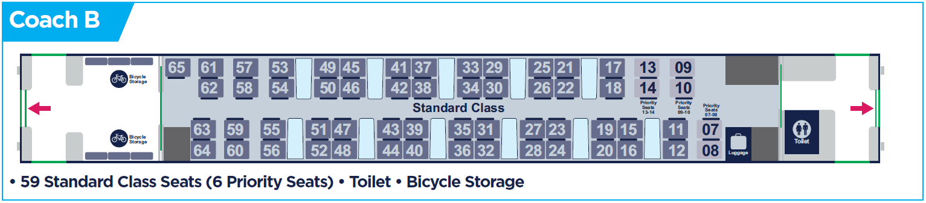
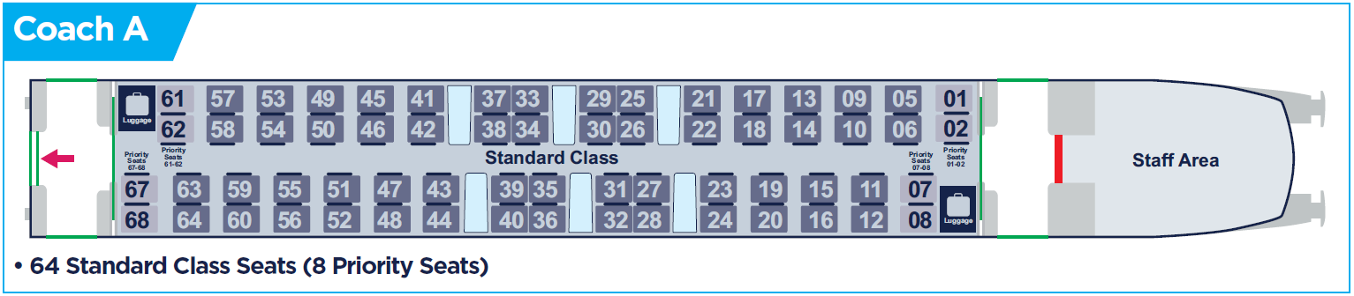

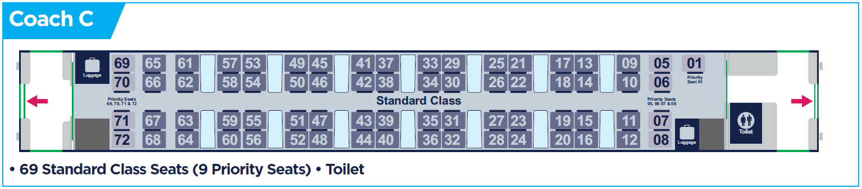
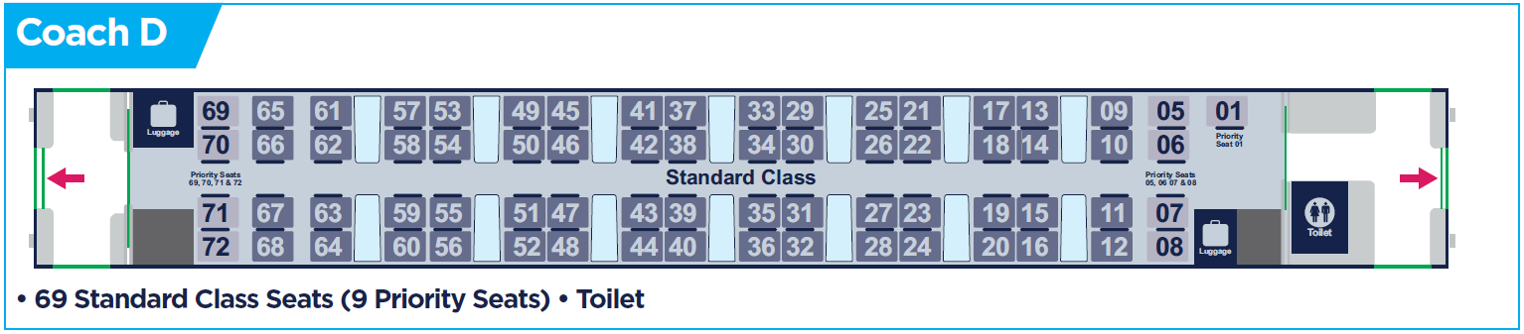

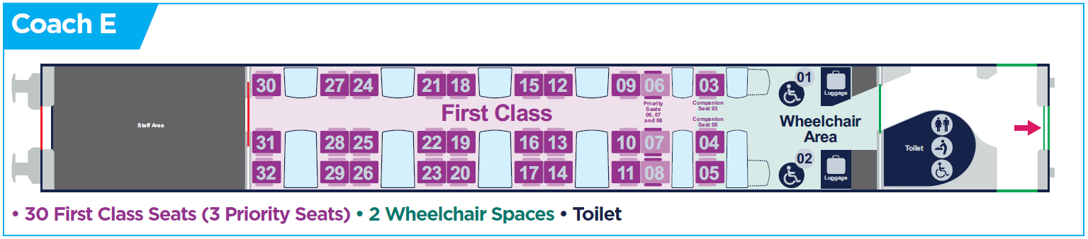

Access Summary
Train Type
TransPennine Express NOVA 3
Primary Operating Routes
Liverpool Lime Street to Scarborough
Manchester Airport to Middlesbrough

RVAR / PRM-TSI | PRM-TSI
Accessible Toilets | Yes  Accessible toilet in coach E, next to the wheelchair user spaces, equipped with baby changing facilities
Wheelchair User Spaces | 2  Located in coach E (First Class)
On Board Ramps | Yes  Located in coach E vestibule
Passenger Info System | Yes  Audio/Visual announcements with digital customer information screens
Priority Seats | Yes  32 standard class  3 first class
Contrasting grab rails | Yes
Tactile or Braille Notices | Tactile

Contact Us
If you have any more questions about these trains, or to book assistance, please contact our Assisted Travel Team

By Phone

0800 107 2149

18001 0800 107 2149 (TextRelay)
For comments and complaints, lines are open 06:00 to 23:00 seven days a week, including Bank Holidays, except Christmas Day. For assistance bookings, our operating times vary dependent upon the journey you are making. Please see the Passenger Assistance Bookings section of this policy for more details.

Online
Visit tpexpress.co.uk and click on travelling with us, then assisted travel to find more information or request assistance using the online form.

By Post
If you wish to write to us, please use the postal address below:

TransPennine Express

Customer Relations

Admail 3878

FREEPOST

Manchester

M1 9YB

